**Patricio Vargas**

**870406220**

**1) Let *X* denote the processing time for a particular drilling operation. There are three types of parts: A, B, and C. Thirty percent of type A, sixty five percent of type B, and five percent of type C. Drill time for a type A is exponential with mean 3.2 minutes. Drill time for a type B is uniformly distributed between 1.2 and 2.0 minutes. Drill time for a type C part is deterministically 0.5 minutes. Parts arrive randomly and independently to the drill.**

**a) Develop a model for the processing time.**

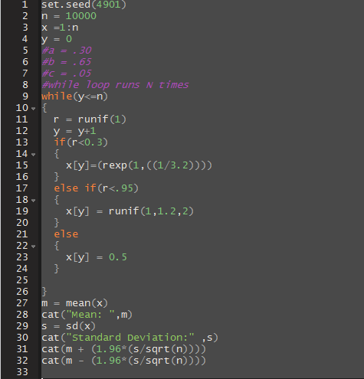

**b) Use simulation to find the expected processing time.**

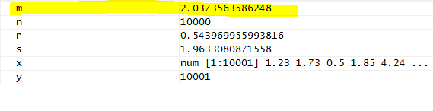

**c) Report a 95% confidence interval for mean processing time.**

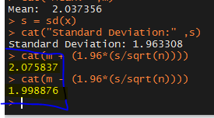

We are getting this result when pour process interval is at 95%, it that being said our intervals go from 1.998893 all the way to 2.075858

**2. (Box-Muller Method) If 𝑈1 and 𝑈2 are independent Uniform(0,1) and**

**𝑋1= √−2ln(𝑈1) cos (2𝜋𝑈2)**

**and 𝑋2= √−2ln(𝑈1) sin (2𝜋𝑈2)**

**Use simulation to generate pairs of 𝑋1and 𝑋2.**

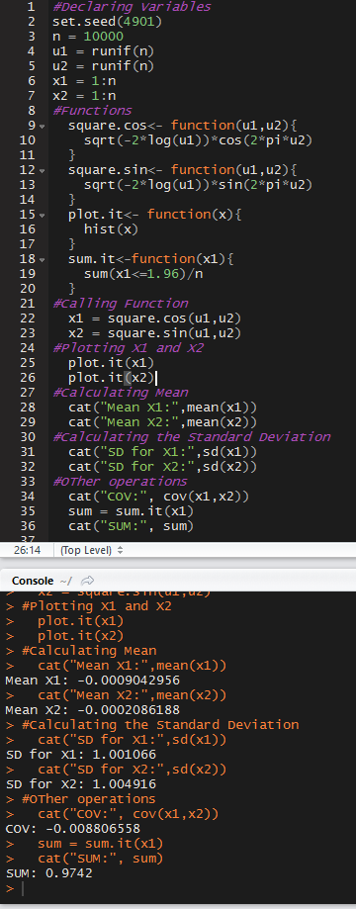

1. **Plot histograms for 𝑋1and 𝑋2. Do they look like normal distributions?**

After analyzing the plots we can conclude that the states of these 2 plots are normally distributed. Also, if we take a look to the plot number 1 we will noticed that our **x1** is more lean toward the values that are smaller where in **x2** is the opposite it, it leans towards the bigger values

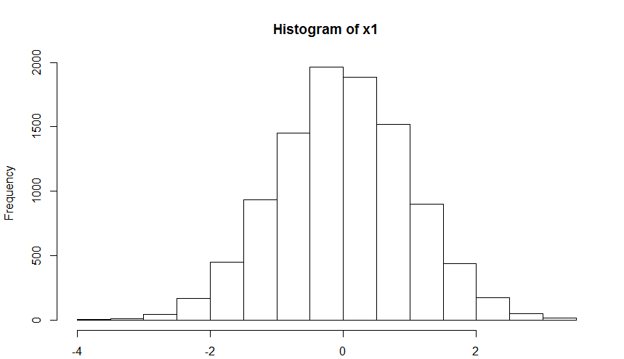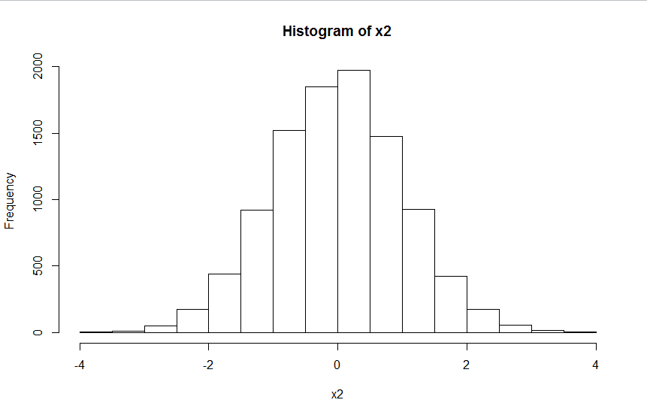

1. **Report means and standard deviations for 𝑋1and 𝑋2**.

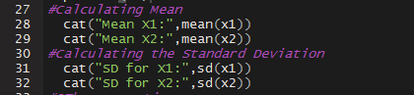

**c) Report covariance of 𝑋1and 𝑋2. Are they independent? Why? They are independent because the covariance is close to zero.**



**d) Use simulated data of 𝑋1 to calculate (𝑋1≤1.96).**



**3) Develop a simulation for the following problem. The management of Madeira Manufacturing Company is considering the introduction of a new product. The fixed cost to begin the production of the product is $30,000. The variable cost for the product is uniformly distributed between $16 and $24 per unit. The product will sell for $50 per unit. Demand for the product is best described by a normal probability distribution with a mean of 1200 units and a standard deviation of 300 units. Use simulation trials to answer the following questions:**

1. **What is the mean profit for the simulation?**



1. **What is the probability that the project will result in a loss?**



1. **What is your recommendation concerning the introduction of the product?**

The money that the company has for the intro is enough for get this first stage running, If the company wants to expect a higher return on their investment they will have to market the product and they will have to insure they take the product out of the product stage, after this, the company will start making way more profit, another way of making more profit is when they decide to do more simulations and add more products to the first state which is the production stage.

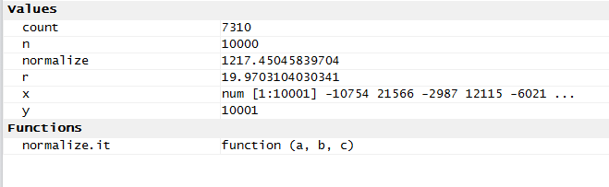

**4) A student of mine was asked this question in an interview. “Consider the following game: A cup is filled with 100 pennies. The cup is shaken, and the pennies are poured onto a table. If at least 60 of the pennies are Heads, you win $20. Otherwise, you lose $1. Is this a good game to play?” (That is does it have a positive expected value?). Answer this using simulation in R. It is not a good game to lay.  
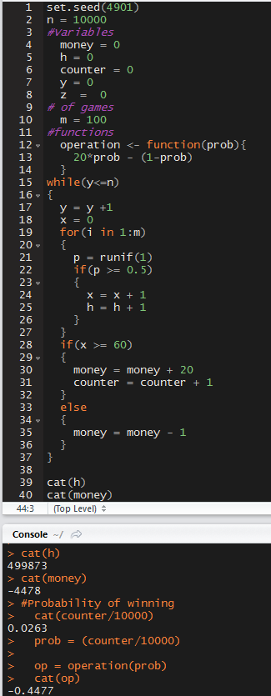**

**a) Determine how much you would win or lose. If you played 10,000 you would win roughly 263 games.**



If we run this simulation 10k times our money will become **-$4477, so we will lose money**

**b) Does it appear to be a fair game? It is not a fair game because the win-to-lose proportion.**

If we don’t analyze this problem we will think that is an easy win for whoever plays agains the “house”, but the truth is after running the simulation that, you will be losing more money that the one you are actually winning, remember that the house never loses.

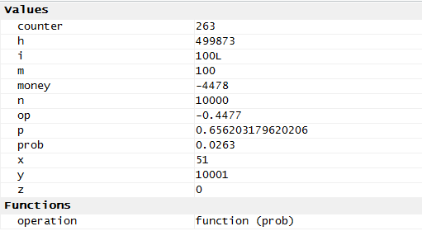

**5) In the game of Chuck-A-Luck a player tosses three dice and earns a dollar for each 6 that appears. It costs one dollar for each roll of the three dice. Let X be the random variable representing the dollar amount won in a single roll of the three dice minus the dollar spent to play. Example: if the player rolls (6, 2, 6), then X = 1.**

**Write R code to simulate the game of Chuck-A-Luck in the following steps.**

1. **Write a function to simulate a roll of Chuck-A-Luck. The function should return the amount won minus the dollar spent (i.e., the random variable X from above.)**

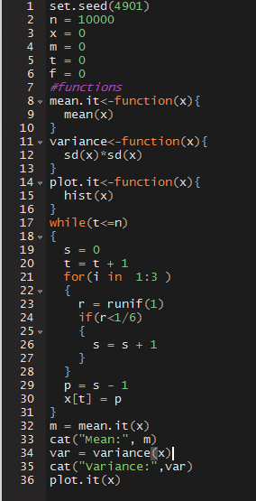

1. **Run your function and compute the sample mean and variance for this simulation.**

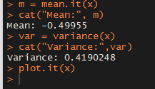

1. **Plot a histogram of the X variable. Is the histogram symmetric about the mean?**

**After analyzing the graph listed below we will see that we are losing money, we are losing 50 cents of a dollar, after seeing this graph we conclude that after we run the simulation N times, our plot wont be symmetric**

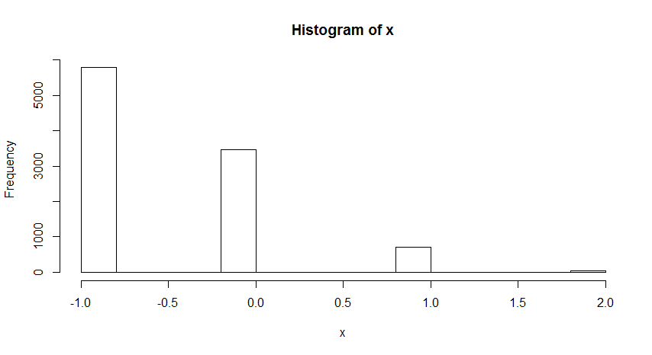

**6) A salesperson in a large bicycle shop is paid a bonus if he sells more than 4 bicycles a day. The probability of selling more than 4 bicycles a day is only 0.40. If the number of bicycles sold is greater than 4, the distribution of sales is as shown in the table below. The shop has four different models of bicycles. The amount of the bonus paid out varies by type. The bonus for model A is $10; 40% of the bicycles sold are of this type. Model B accounts for 35% of the sales and pays a bonus of $15. Model C has a bonus rating of $20 and makes up 20% of the sales. Finally, model D pays a bonus of $25 for each sale but accounts for only 5% of the sales.**

